**CURRENCY CONVERTER**

**PROGRAM**

Public Class WebForm2

Inherits System.Web.UI.Page

Public ccr_USD_INR As Double = 68.9

Public ccr_JPY_INR As Double = 1.67

Public result As Double

Private Sub DropDownList1_SelectedIndexChanged(sender As Object, e As EventArgs) Handles DropDownList1.SelectedIndexChanged

If TextBox1.Text = "" Then

MsgBox("Please enter a value before converting currency")

Else

If DropDownList1.SelectedItem.Value = "INR_USD" Then

result = Math.Round(Convert.ToDouble(TextBox1.Text) / ccr_USD_INR, 2)

TextBox2.Text = result.ToString() + " USD"

ElseIf DropDownList1.SelectedItem.Value = "USD_INR" Then

result = Math.Round(Convert.ToDouble(TextBox1.Text) * ccr_USD_INR, 2)

TextBox2.Text = result.ToString() + " INR"

ElseIf DropDownList1.SelectedItem.Value = "INR_JPY" Then

result = Math.Round(Convert.ToDouble(TextBox1.Text) / ccr_JPY_INR, 2)

TextBox2.Text = result.ToString() + " JPY"

ElseIf DropDownList1.SelectedItem.Value = "JPY_INR" Then

result = Math.Round(Convert.ToDouble(TextBox1.Text) * ccr_JPY_INR, 2)

TextBox2.Text = result.ToString() + " INR"

End If

End If

End Sub

End Class

**DropDownList1 – Property**

AutoPostBack – True

Items – Add data

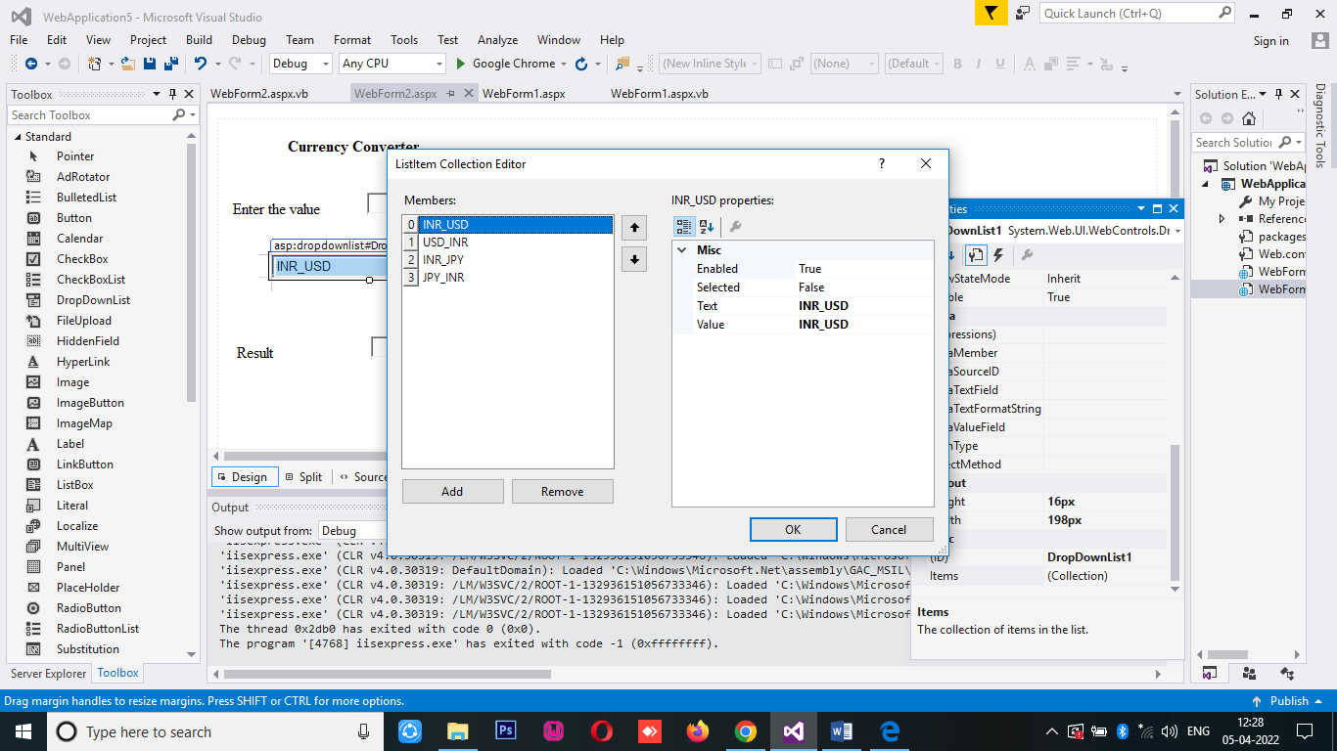

**OUTPUT**

